VMware is well known and has a reputation for ease of use. Many of its core products are free of charge (but not open source).

With an AMD x86_64 Ubuntu OS as host, it is necessary to install ia32-libs prior to using it.

1. [VMware Player](https://help.ubuntu.com/community/VMware/Player) is the most basic version of VMware available. It's designed to play existing VM images. There are many existing, downloadable images for free Operating Systems. In addition, sites like [EasyVMX](http://www.easyvmx.com/) allow for free creation of new VMXs, allowing Windows to be installed and run in VMware player.
2. [VMware Workstation](https://help.ubuntu.com/community/VMware/Workstation) is more advanced, and includes a built-in VM creator, as well as the ability to capture an OS snapshot at any point in time. With VMWare Workstation you can also [use an existing physical partition as a virtual machine](https://help.ubuntu.com/community/VMware/Workstation/NativeVirtualMachine). VMware workstation requires a paid license to use.
3. [VMware Server](https://help.ubuntu.com/community/VMware/Server) is aimed at hosting virtual servers. It includes a configuration console and web based configuration access. This is also free from VMware. AMD64 users should see [VMware/Server/AMD64](https://help.ubuntu.com/community/VMware/Server/AMD64)

What are 'VMware Tools'?

The VMware Tools are software installed on a guest VM for improving performance when running on a [VMware/Esx](https://help.ubuntu.com/community/VMware/Esx), [VMware/Player](https://help.ubuntu.com/community/VMware/Player), [VMware/Server](https://help.ubuntu.com/community/VMware/Server) or[VMware/Workstation](https://help.ubuntu.com/community/VMware/Workstation) host. The tools provide:

1. VMware Network acceleration
2. VMware Video acceleration
3. Host to Guest time synchronization
4. Seamless mouse movement between host and guest
5. Cut & Paste - Guest to Host and Guest to Guest (with VMware Toolbox) (possibly only on gnome)
6. Disk Shrink (with VMware Toolbox running at root)
7. Startup/Shutdown Scripts (with VMware Toolbox running at root)
8. [HeartBeat](https://help.ubuntu.com/community/HeartBeat) ([VMware/Esx](https://help.ubuntu.com/community/VMware/Esx) only ?)

**This page explains how to install the VMware Tools on an Ubuntu guest VM.**

## Installing VMware tools on an Ubuntu guest

VMware tools can be obtained from:

1. the open-vm-toolspackage in Ubuntu
2. packages.vmware.com
3. your VMware host (this method does not use .deb packages)

### Installing from Ubuntu package open-vm-tools

The VMware tools are part of [open-vm-tools](http://open-vm-tools.sourceforge.net/). Make sure that the [''multiverse'' repository is enabled](https://help.ubuntu.com/community/Repositories/CommandLine#Adding Repositories) and do:

# on 12.04 LTS you can simply install the package:

apt-get install open-vm-tools

# on earlier versions, use this workaround:

# install kernel headers so modules will work

# needed this on a 10.04 guest running in a Fusion 3 host

apt-get install linux-headers-virtual

# install kernel modules

apt-get install --no-install-recommends open-vm-dkms

# EITHER: install tools for an xorg install

apt-get install open-vm-tools

# OR: a headless install

apt-get install --no-install-recommends open-vm-tools

.

To add the repository and install tools :

ESX 4.1: apt-add-repository 'deb http://packages.vmware.com/tools/esx/4.1latest/ubuntu lucid main restricted'

ESX 5.0: apt-add-repository 'deb http://packages.vmware.com/tools/esx/5.0latest/ubuntu lucid main restricted'

wget http://packages.vmware.com/tools/keys/VMWARE-PACKAGING-GPG-RSA-KEY.pub -q -O- | \

apt-key add -

# (The above links to the ESX "4.1latest" builds of VMware-tools; however,

# these packages should be compatible with all VMware servers, not just ESX 4.1)

apt-get update

apt-get install vmware-open-vm-tools-kmod-source

module-assistant prepare

module-assistant build vmware-open-vm-tools-kmod-source

# depending on your kernel version, you may need to specify the path to headers like this

# module-assistant build vmware-open-vm-tools-kmod-source -v -t -k /usr/src/linux-headers-2.6.35-25-server/

module-assistant install vmware-open-vm-tools-kmod

# EITHER: install tools for headless system

apt-get install vmware-open-vm-tools-nox

# OR: install for Xorg system

apt-get install vmware-open-vm-tools

### Installing from your VMware host

sudo apt-get install build-essential linux-headers-`uname -r` psmisc

# make a mount point if needed :

sudo mkdir /media/cdrom

# Mount the CD

sudo mount /dev/cdrom /media/cdrom

# Copy and extract VMWareTools

sudo cp /media/cdrom/VMwareTools*.tar.gz ~/Desktop

# You can extract with archive manager, right click on the archive and extract ... or

tar xvf VMwareTools*.tar.gz

# Install as below

Open a terminal window, and run the following commands.

cd ~/Desktop/vmware-tools-distrib

sudo ./vmware-install.pl

During vmware-install.pl, choose the default answers to everything (just hit the <enter> key).

You can configure the tools as root

sudo vmware-toolbox

Otherwise run them as a user (not root)

vmware-toolbox

1. In order for the synchronized clipboard and mouse to function as well as the host shared folders feature, you must have vmware-toolbox running, although you can minimize the window.

To have vmware tools auto start with your sessions, go to System->Preferences->Sessions->Startup Programs. Click Add, enter vmware-toolbox, Ok, Close.

If you are running a Kubuntu guest OS.

echo "/usr/bin/vmware-toolbox" > ~/.kde/Autostart/vmware-toolbox.sh

chmod +x ~/.kde/Autostart/vmware-toolbox.sh

In order to get the scroll wheel to work again after the above install, you will need to make a minor change to the xorg.conf file.

In the "Configured Mouse" section, change the following line as indicated:

Option "Protocol" "imps/2"

If you have more than five buttons (scroll wheel counts as three), then you might need the following line:

Option "Protocol" "ExplorerPS/2"

Restart X.

**Vmware account detail:**

Sir, I created an account with vmware

**Mail ed:praveenthovinakere@gmail.com**

**Worked tools:**

1.I download and worked with vm work station-10

2. I downloaded and worked with VM player

**Benefits from VMWARE**:

Compare to oracle virtual box,its very userfriemdly to use,it works fast and smooth usage

**OUTPUTS:**

1.This is the screen shot of vm workstation :

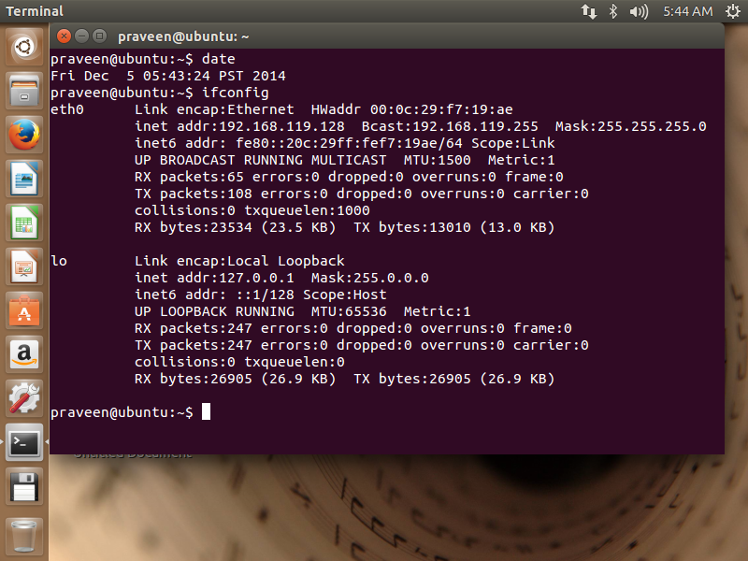

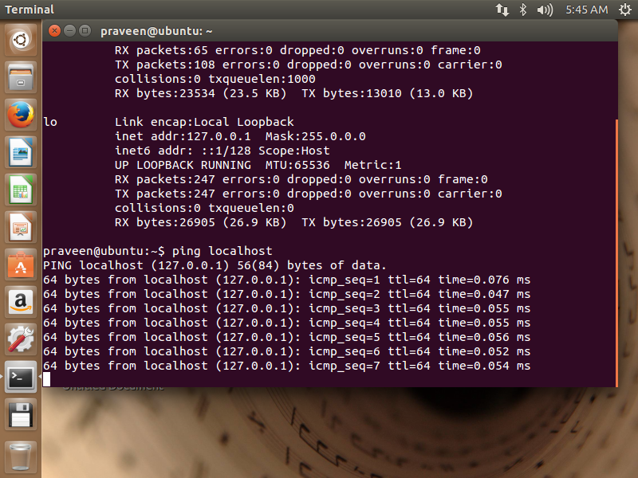

2.VM WARE PLAYER:

